Owner Satisfaction Survey Winner 2013

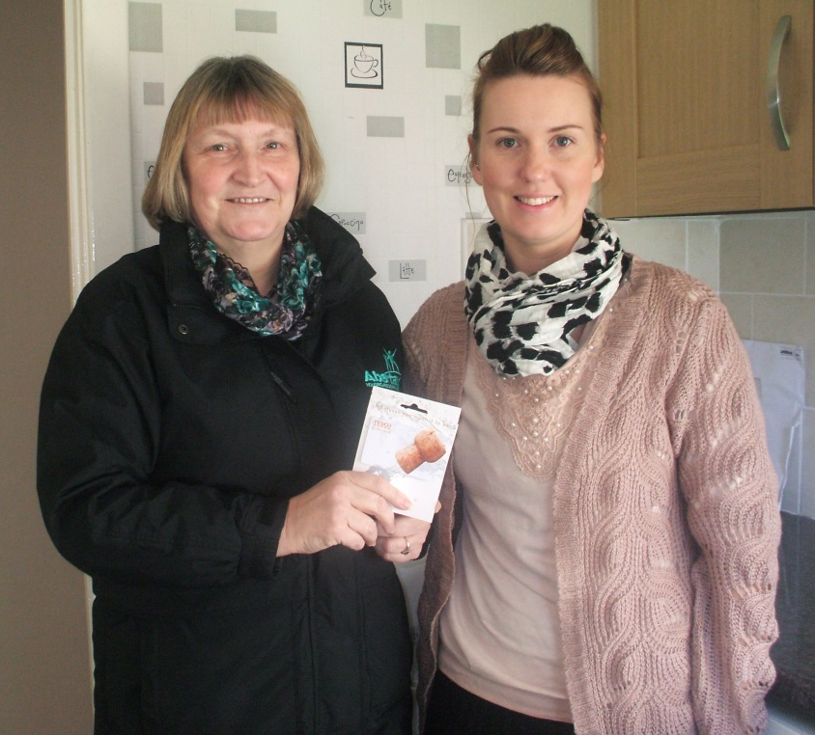

£40 Tesco Voucher courtesy of McGill
Ms Fotheringham, Kingsway West estate.

